Notes

Introduction

Context

Woodland caribou (forest-dwelling ecotype) has become emblematic of the direct and indirect effects of human disruptions of boreal forest landscapes because of its sensitivity various to landscape disturbances such as logging and the associated development of road networks. Consequently, it is a central /recurrent topic in the continuing discussion about balancing ecological, social and economical values associated with North American boreal forest.

“boreal caribou (hereafter referred to as caribou), an ecotype of the woodland caribou subspecies (Rangifer tarandus car- ibou), threatened and declining throughout much of its range (Vors and Boyce 2009, Environment Canada, 2011)“

While risk assessment is typically associated with predation, it nonetheless involves multiple factors that combine to affect levels of uncertainty associated with a given habitat. Some ecologists have proposed that anthropogenic disturbances (i.e. habitat alterations, resource exploitation and human presence and infrastructure; hereafter called disturbances) could trigger behav- ioural responses that are similar to those elicited by predators (...) (Frid and Dill 2002; Beauchesne et al. 2013)

“Of greatest concern, timber harvesting creates early-seral forests and a dense road network that significantly alters the natural structure of the landscape [17]”

“This species offered a unique opportunity to study the fine-scale movements of species typically associated with mature forests yet inhabiting heavily managed environments [20]. Naturally adapted to cope with natural disturbances across their range [21], remnant caribou populations have nonetheless suffered severe constrictions of their range that are strongly correlated to forestry activities [14,22–23]. The early successional forests created by harvesting jeopardizes the anti-predation strategy used by caribou (i.e. spacing out; [24]) by favouring local increases in moose Alces alces [25], gray wolf Canis lupus [26] and black bear Ursus americanus densities [27]. As a consequence, encounter rates between caribou and predators increase [28–29], exacerbating caribou vulnerability (Beauchesne et al. 2013)

Like other wildlife species, the woodland caribou has been found to respond to limiting factors across multiple spatiotem- poral scales, with predation avoidance on the one hand [4,24] and disturbances on the other [7,22] influencing large-scale behaviour, while biological requirements are met at finer scales [30]. (Beauchesne et al. 2013)

“It thus seems that predation risk and anthropogenic disturbances act synergistically and impact individual vulnerability, ultimately affecting populations through decreases in reproductive output and survival [1]. (Beauchesne et al. 2013)

Landscape disturbances
Anthropogenic disturbances
Roads
Harvesting
Others
Cover types
deciduous (Predation)
young (open)

Climate change
Amplifying effect through changes in forest cover

Ultimately, projecting future caribou habitat and balancing forest harvesting with caribou conservation requires the integration of these dimensions and their associated uncertainties.

Objectives

The main objective of this study is to yield projection of future woodland caribou habitat over a spatiotemporal horizon relevant to strategic planning (100 yrs, 10Mha) by coupling a woodland caribou resource selection function (RSF) developed for the purpose of this study with a recently published climate sensitive simulation ensemble of forest cover.

More specifically, we integrate climatic uncertainty on future woodland caribou's habitat by considering a wide array of climate change scenarios and their impacts on forest cover. Likely impacts of climate change through alteration of stand-level species interactions are considered as well indirect impacts through modification of fire regime.

Various harvesting level are also included in the projection envelope.

By considering all those source of uncertainty in a simulation ensemble, we aim to obtain a more realistic view of the uncertainty associated with that species' future habitat. Also, and perhaps most importantly, we aim to document the relative importance of each driver of change through a sensitivity analysis, which can in turn allow to inform the conservation strategies that are most likely to be effective.

There is some irreducible amount of uncertainty that will always be associated with projections made for that kind of spatiotemporal scales. Focusing on documenting the most important drivers of changes allows to put our projections into a broader perspective; to inform about conservation strategies that are most likely to be effective despite uncertainty, and identify scientific and technical areas of knowledge where further efforts are most needed.

Methods

“A resource selection function (RSF) is any model that yields values proportional to the probability of use of a resource unit” (Boyce et al. 2002)⁠.

In the case of models built using radio telemetry data the appropriate design structure is one of presence versus availability, i.e. characterizing a sample of sites where the organism is present from a sample of what is available on the landscape.

In all cases, a set of predictor variables is selected a priori using hypothesized habitat relations based on the ecology of the organism (Burnham and Anderson, 2001).

A concern with the used-versus-unused approach to fitting RSF models is that it may be difficult to demonstrate non-use, especially for mobile and cryptic animals. Also, non-use can depend on sampling intensity, so that a more extensive search might result in unused sites being reclassified as used sites.
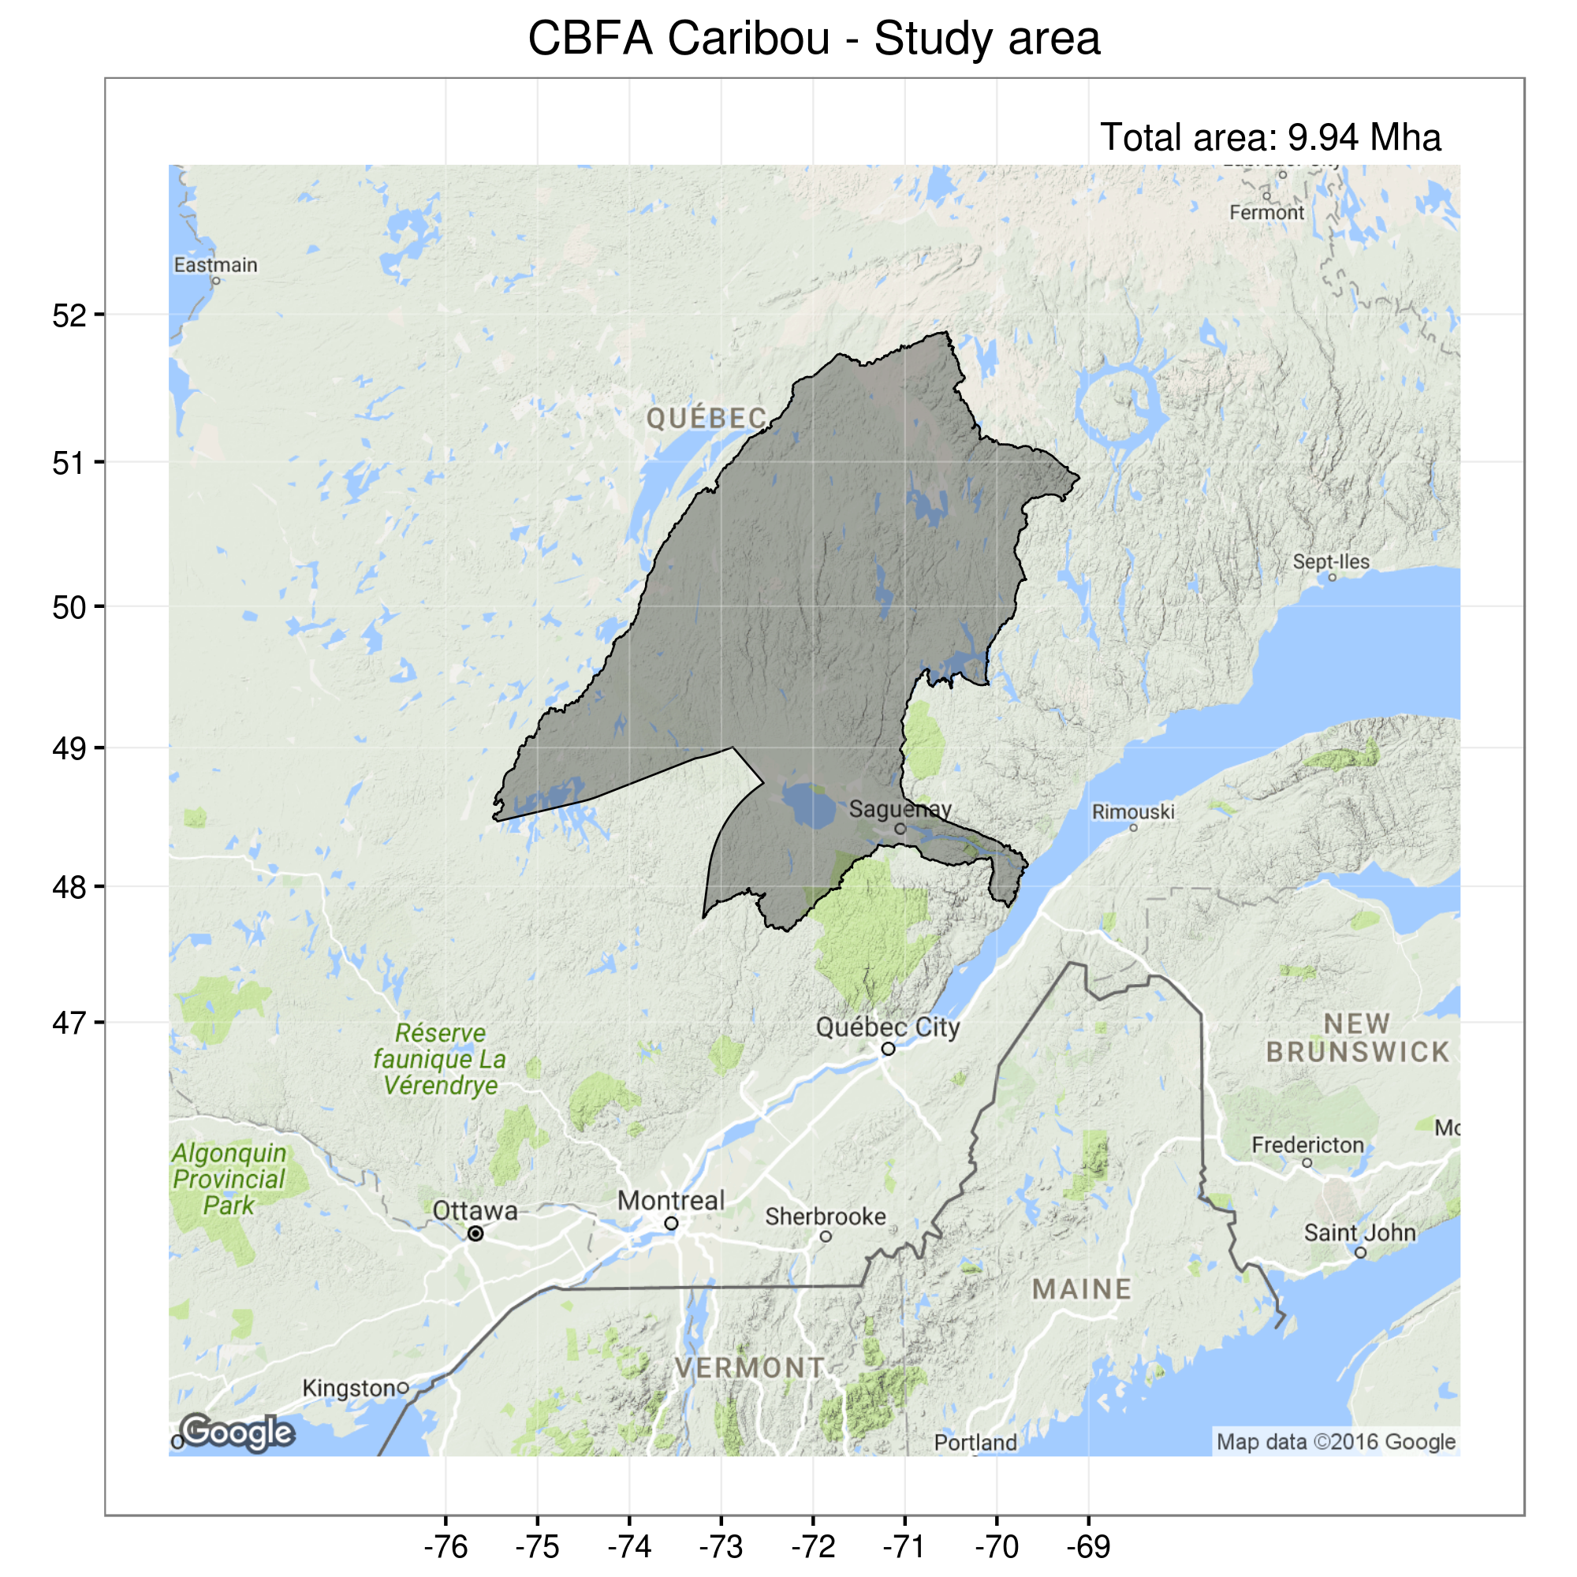Figure 1. Study area

Table 1. Definition of predictor variables in the woodland caribou resource selection function
Variable | Variable type | Range of values  (units) | Description | Availability  (empirical dataset) | Availability  (simulated area)
Fire 0-9 | binary | 0 – 1 | Forest cover 0 to 9 yr-old, originating from fire | 12.1% | 1.6%
Harv 0-9 | binary | 0 – 1 | Forest cover 0 to 9 yr-old, originating from harvesting | 3.3% | 4.8%
Fire 10-49 | binary | 0 – 1 | Forest cover 10 to 49 yr-old, originating from fire | 2.7% | 4.8%
Conif harv 10-49 | binary | 0 – 1 | Forest cover, ≥50% coniferous, 10 to 49 yr-old, originating from harvesting | 8.4% | 4.6%
Conif other 10-49 | binary | 0 – 1 | Forest cover, ≥50% coniferous, 10 to 49 yr-old, originating from other disturbances | 16.6% | 1.2%
Decid harv 10-49 | binary | 0 – 1 | Forest cover, >50% deciduous, 10 to 49 yr-old, originating from harvesting | 0.1% | 1.0%
Decid other 10-49 | binary | 0 – 1 | Forest cover, >50% deciduous, 10 to 49 yr-old, originating from other disturbances | 0.2% | 0.3%
Conif 50-89 | binary | 0 – 1 | Forest cover, ≥50% coniferous, 50 to 89 yr-old | 28.8% | 16.4%
Decid 50-89 | binary | 0 – 1 | Forest cover, >50% deciduous, 50 to 89 yr-old | 0.2% | 2.5%
Conif 90+ | Binary | 0 – 1 | Forest cover, >50% deciduous, 90 yr-old and more | 11.7% | 48.90%
Wetlands | binary | 0 – 1 | Non forested, wetland. | 1.2% | 1.4%
NonForest | binary | 0 – 1 | Non forested, other (ex. Waterbodies, barren ground, what else?) | 14.7% | 15.5%
RoadEffDist | continuous | 0 – 214.4  (km) | Minimum distance to road, transformed using a decay function* | - | -
biomass | continuous | (à calculer) | Total aboveground tree biomass | - | -

Table 2. Description of simulation ensemble
Baseline climate
Factor | Levels | Number of levels
Climate change scenario | baseline | 1
Fire regime | baseline | 1
Harvesting level | 50%, 100% | 2
 |  | Total: 2
Projected climate
Factor | Levels | Number of levels
Climate change scenario | RCP 2.6, RCP 4.5, RCP 8.5 | 3
Fire regime | baseline, projected¹ | 2
Harvesting level | 50%, 100% | 2
 |  | Total: 12
¹Fire regimes projections are associated with the climate change scenario being simulated, i.e. with the appropriate RCP.
All simulated treatments were replicated 5 times, accounting for a total of 70 simulations.

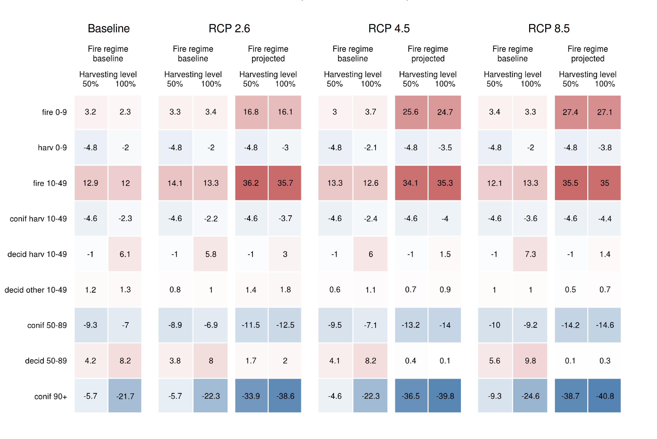Table 3. Projected deviation in availability of cover types (%) from 2000 to 2100 for each simulated treatment. (Average of 5 replicates per treatment. The more saturated the colour, the stronger the deviation from the initial condition is.)

1- When compared to the baseline scenario, projected fire regimes clearly drive the most notable changes in the relative abundances of forest covers, increasing the overall proportions of young age-classes to the detriment of older cover types.

2- The simulated harvesting treatments appear to come second in terms of relative importance. However, a notable increase in the proportions of deciduous cover types is obtained when the harvesting level is 100%, for all age-classes, in all climate change scenarios.

3- Generally, the more intense the climate forcing are associated with the more important changes in relative abundances of forest covers, but not always. Anyway, this pattern is clearly secondary to those associated with disturbances treatments.

4- Some changes are notable even under the baseline scenario, with a notable decrease in the relative proportion of old coniferous cover type being associated with the baseline scenario with a 100% harvesting level, as well as an increase in the amount of recently burned areas.

5- Overall, the most stable conditions in terms of forest covert are obtained when harvesting level is at 50%, and fire regime remains that of the baseline scenario, with very little effects of the climate change scenario being simulated.

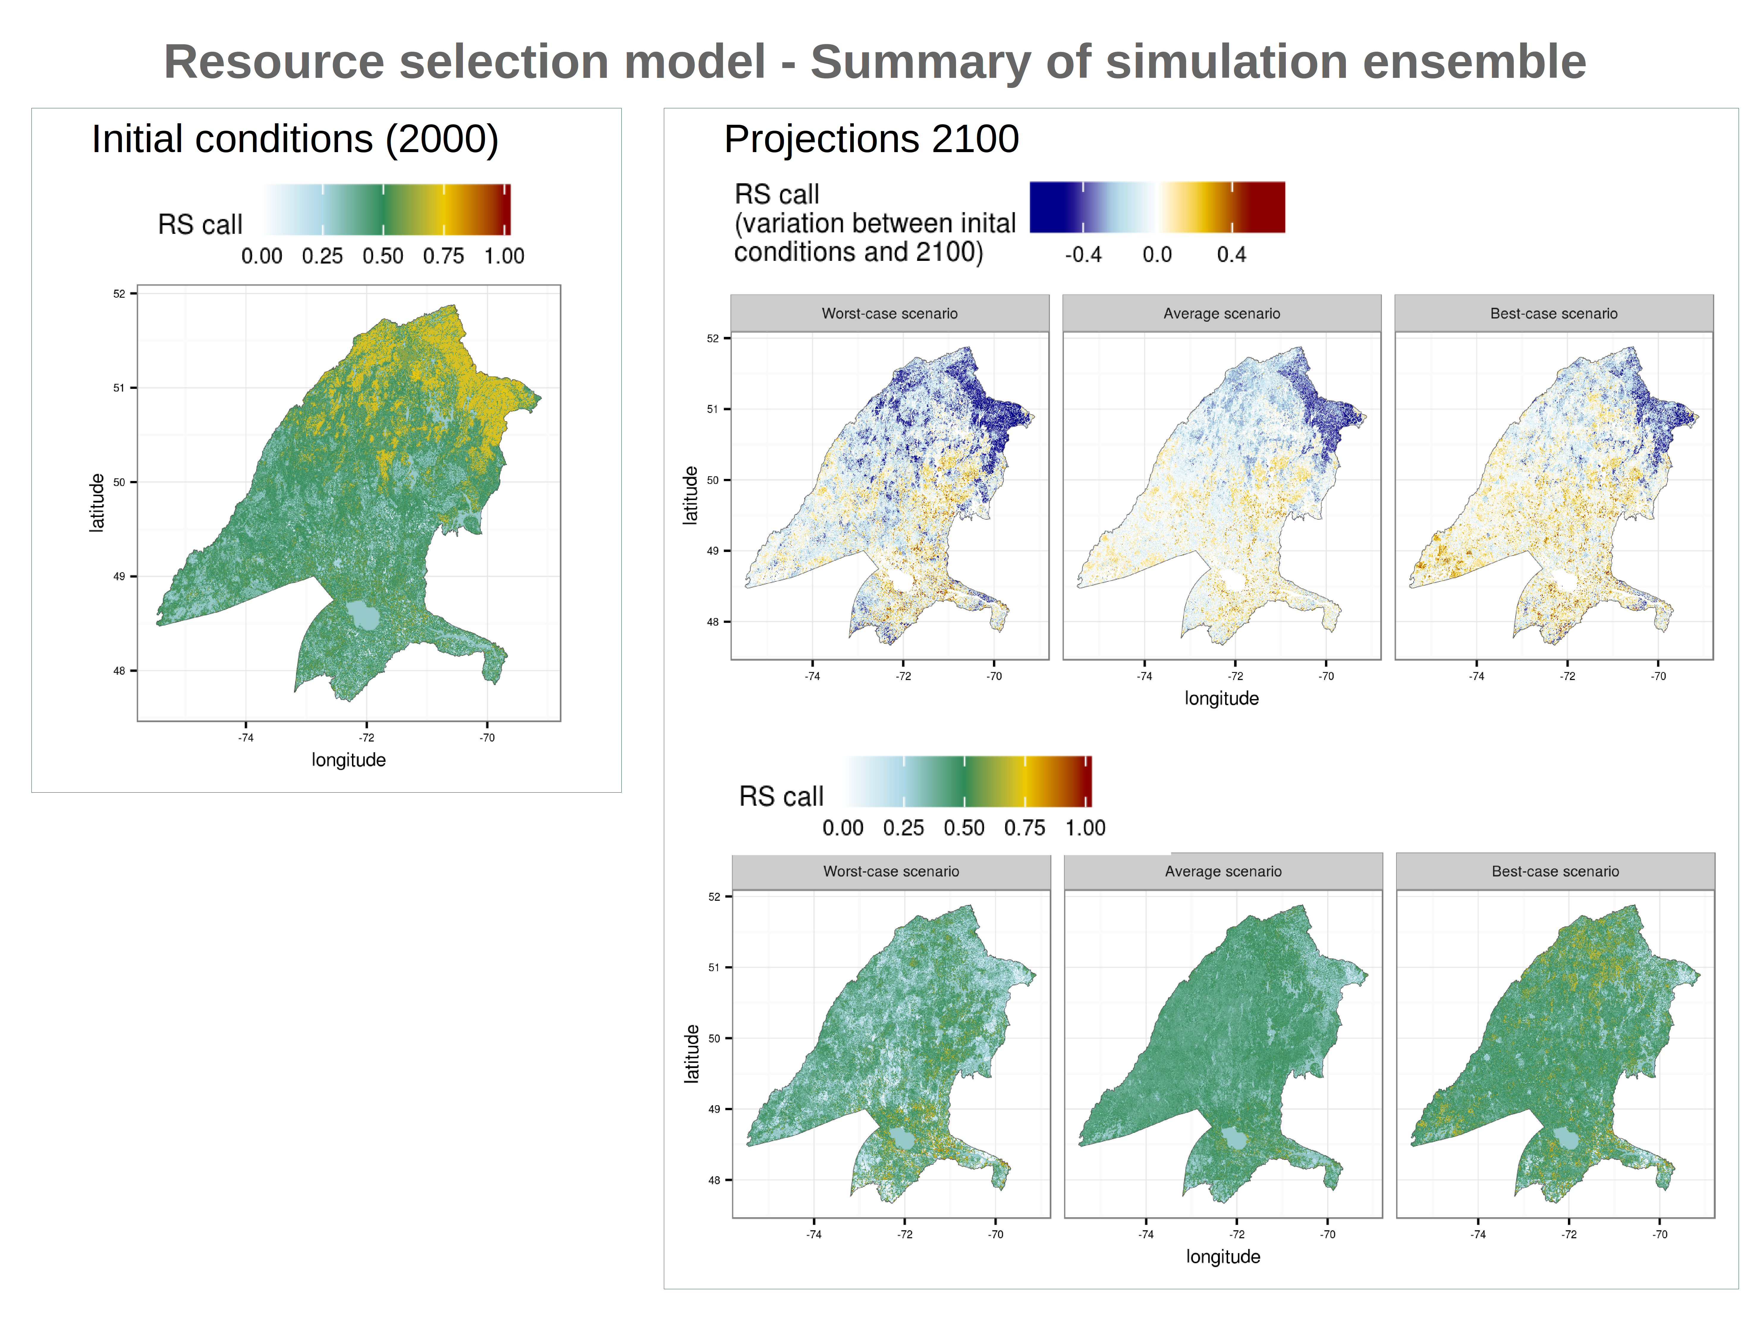Figure 2. Predictions of woodland caribou resource selection function – Summary of the simulation ensemble showing initial conditions (left), as well as the projected deviation from initial conditions in 2100 (top-right) and resulting landscapes (bottom-right). Only projected climate scenarios were considered to designate worst- and best-case scenarios as well as to compute average scenario.

1- The initial state of the simulation area presents a clear south-north partitioning in terms of values predicted by the RSF. The initial spatial pattern follows quite closely that of the current road network (suppl. Mat), which in itself affect the result of the RSF, but with which many other predictors are also correlated (suppl. Mat).

2- A general pattern appear to be common to all simulations, i.e. a decrease of average RS calls in the northern part of the simulation area, north of the 50th parallel, especially in its northeastern portion. On the contrary, an increase of the average RS calls is generally obtained south of the 50th parallel, although the worst-case scenario is a little less optimistic in that regard.

3- Consequently, the final average scenario is a very homogeneous landscape of mediocre caribou habitat quality, with only very spots of higher quality habitats (warmer colours) sparsely distributed mainly in the northwestern portion of the area in the best-case scenario. In the worst-case scenario, most of the higher quality habitats are located in the southern portions of the area near the Lac St-Jean, while most of the remaining portions of the landscape being made up of the poorest habitat that can be found nowadays.

Note that each realized landscape were not as homogeneous as any of those presented for the 2100 horizon, as the 5 replicates were averaged out for each simulated treatments.

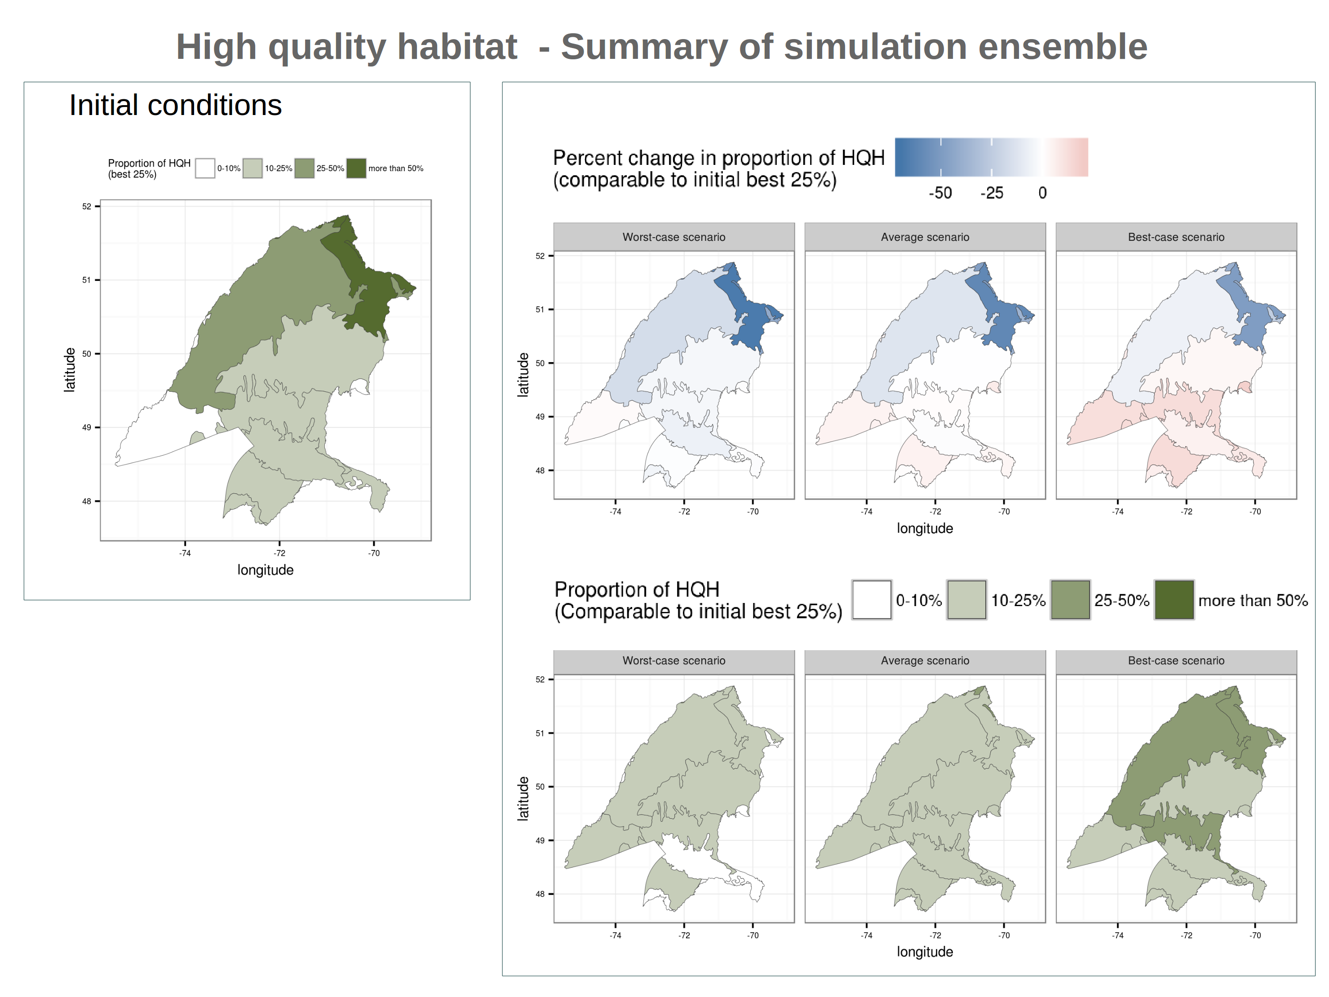Figure 3. Predictions of relative abundance of woodland caribou high quality habitats (HQH) – Summary of simulation ensemble. HQH are based on a threshold defined by the best quartile of initial conditions. Summary of simulation ensemble. Worst- and best-case scenarios are composites maps made up from the extreme scenarios obtained in each ecodistrict after replicates were averaged out. Only projected climate scenarios were considered, no baseline climate.

A similar portrait can be obtained by focusing on the relative abundance of high quality habitat (HQH) in each ecodistrict, HQH being defined as habitat that are comparable or better than the best quartile (25%) in the initial landscape. In this case, however, as opposed to the summary of the raw predictions, the worst- and best-case scenarios are composite maps of the worst and best outcomes in all simulated treatments, after replicates were averaged out.

1- Most of the HQH can be found in the northernmost ecodistricts, especially in the one located at the northeastern portion of the landscape.

2- Again, the best-case scenario present a latitudinal gradient in the final deviation from initial conditions at the 2100 horizon. In that case, a decrease in northern ecodistrict appears to be concurrent to an increase in southern ecodistricts. However, that pattern is not common to the worst-case scenario, and only slightly perceptible in the average scenario.

3- Again, an homogenization of the relative abundance of HQH operates for all simulated treatments.

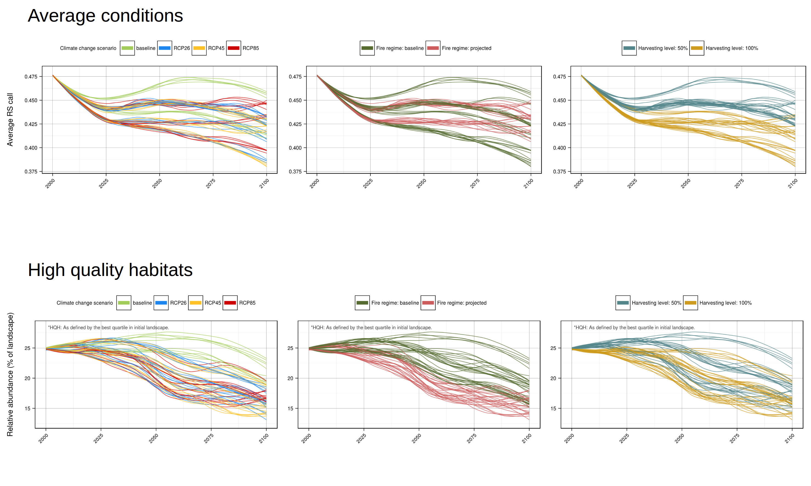Figure 4: Sensitivity analysis of the average quality of the caribou habitat (top), and relative abundance of high quality habitat (HQH; bottom). All panels present the exact same 70 simulations, 14 treatments each replicated 5 times, with colour schemes that decipher them according to a specific factor; namely climate change scenario (left), fire regime (middle), and harvesting levels (right).
In these plots we can visualize the factors that affect the most the evolution of the average quality of the caribou habitat as well as the relative abundance of high quality habitats (HQH).

1- The harvesting levels appears to be what affects the most the average quality of the caribou in this area, as this factor is clearly the one that allows to create the4 most distinct groups, accounting for about half of the uncertainty in final outcomes.

2- Then follows the fire regimes, and finally climate change scenarios, which both allow to create distinct groups but that clearly don't explain as much of the variations among simulations.

3- It should be noted that fire regimes treatments are coupled with climate change scenarios. Consequently, most of the uncertainty related to climate is in fact mediated by fire regimes.

4- In the case of HQH, it is the fire regime rather that the harvesting levels with which most of the uncertainty is associated. Then follows harvesting levels, and finally the climate change scenarios, which account for a very small portion of the uncertainty associated with the final outcomes.

Discussion

Put the results in a broad context – One paragraph
Projections offer a relatively grim portraits of future caribou habitats, with predominantly negative trends.
Although there are some important processes that are currently left out of our setup, our simulation set up seems to capture quite well some other important ongoing processes such as...
The projection envelope is associated with considerable uncertainty, which is in itself quite informative about 1- the important processes to include in future work, 2- the important processes for wich 2- to consider in conservation strategies, and 3- that It's important to show that we don't know more about the system that what we know. This is a tool that is built to be iteratively improved.
Projected trends
Continuation of an already ongoing process.
Potentially accentuated by effect of climate changes, mostly indirect ones.

First focus on cover, then statics components that we included, and then stuff that wasn't considered.
Caribou habitats requirement

Limits of our methods, yet caribou have shown some behavioral adjustments in face of heavily disturbed habitat.

“While increased use of edges and roads could lead to greater predation risk [58–59], females that are decreasing their crossing rates may become trapped in sub-optimal habitats and disrupt crucial biological activities [1].Such a response could have dire consequences for individual survival [63] and seems analogous to responses exhibited at coarser scales, with individuals decreasing space use as disturbance levels increase over certain thresholds [31]. Alongside further local increases in disturbances, females trapped in sub-optimal habitats could ultimately be forced to spend more time foraging and less time assessing risk as they become energetically depleted [9].” (Beauchesne et al. 2013)

“Edges are known to alter species interactions [55] and may be particularly significant for caribou as edges are used by moose [56] and wolves [57–58]. (Beauchesne et al. 2013)

“Females were gradually less likely to be found within clearcuts as stands aged, suggesting a temporal evolution of the likelihood of female visiting clearcuts. Moose – and inciden- tally wolf – densities increase only once young cutovers are regenerating [50–51].Risks of encounter with predators may thus be lower in younger clearcuts [26], increasing the likelihood of caribou using those younger, regenerating habitats [36,46]. Such habitats are nonetheless associated with increased human [12,16] and predator activity [26,28–29], which may explain that females preferred using young clearcuts only in combination with locally available alternative habitats [14]. Furthermore, as regeneration will inevitably replace young disturbances, any benefits would be temporary until those young habitats are colonized by predators and (Beauchesne et al. 2013)

“Conversely, individual caribou increased their use of open habitats mainly during the spring, summer and rut periods, along with an increase in the use of 0–5 year-old clearcuts during late winter. This could potentially be explained by forage requirements superseding risk avoidance during those periods. Foraging opportunities become scarcer as winter progresses [3,60], followed by periods of low body condition in spring and summer that are particularly significant for parturient females [35]. “(Beauchesne et al. 2013)

limits
Spatial
Seasonality
RSF error

dynamic road networks & harvesting spatial patterns
Despite limitations, FLM coupled with RSF show a great potential for projecting caribou habitat, developping and testing forest management strategies and caribou conservation strategies.
The multiple-scale and spatially explicit nature of this approach allow for the integration of the processes that are currently lacking and that are known to play a significant role, in addition to being incorporate various sources of uncertainty in a tractable manner.

